GRAND LODGE LIBRARY- MUSEUM FUND RAISER
TO HONOR PGM G. RAY MARSH
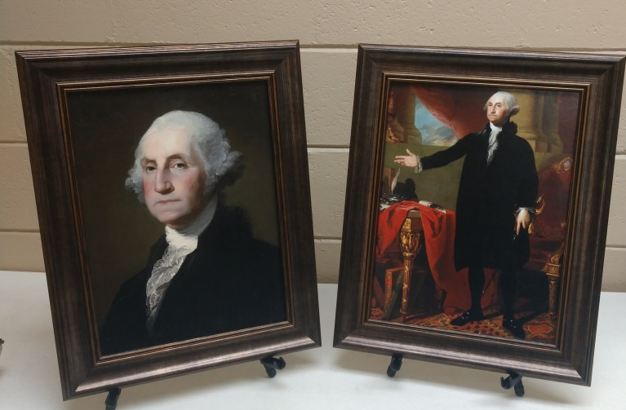
For your office or home
YOUR CHOICE: BUST OR LANSDOWNE
16” X 20” FRAMED
HAND TEXTURED GEL COAT
MOUNTED ON TEMPERED HARD BOARD
Cost: $100.00 ea.  Includes shipping anywhere in SC |  | Choice: |  | Quantity: | Total $
 |  | Bust
 |  | Lansdowne
Make checks payable to: |  |  | South Carolina Grand Lodge  (memo: George Washington Portrait)
Mail checks and order forms to: |  |  | RW Sam Turner III PDDGM  PO Box 248, Roebuck SC 29376
Name

Address

For more information please contact:
RW Sam Turner III, PDDGM (864) 590-7405 samsgarage@upstatemail.net

